**SMART WATER SYSTEM**

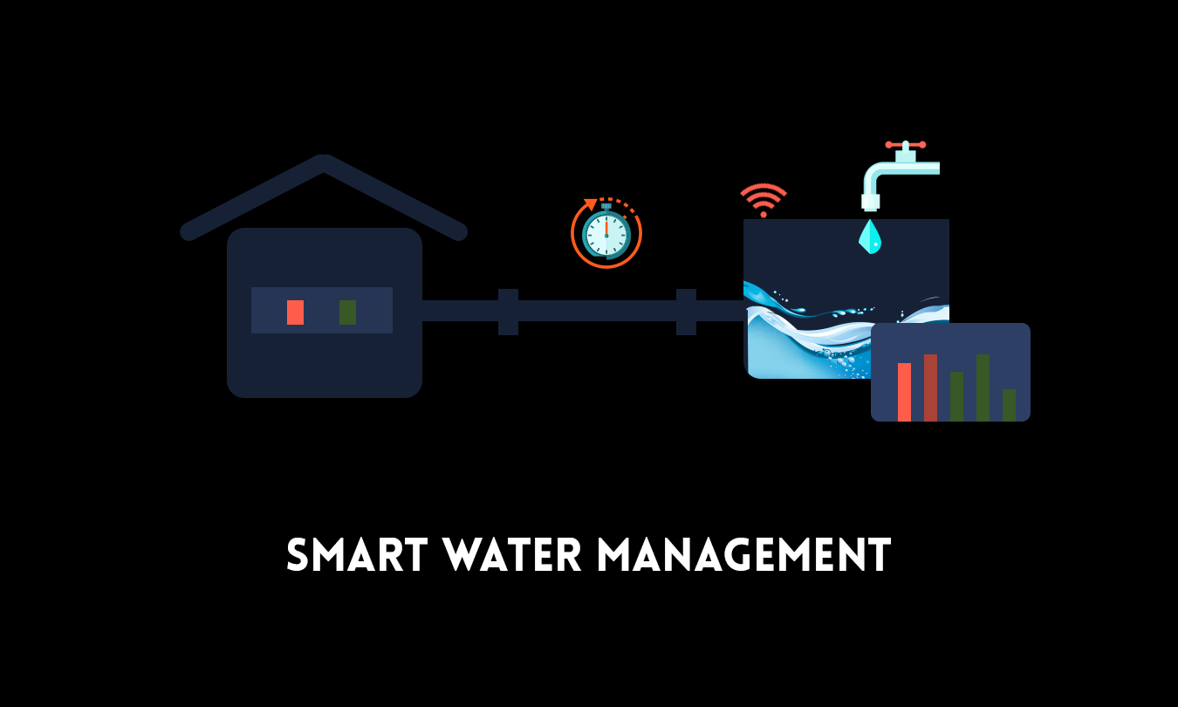

**Abstract:**

IoT-based smart water systems are becoming increasingly popular as a way to conserve water and improve efficiency. These systems use a variety of sensors and other devices to collect data on water usage, quality, and other factors. This data is then transmitted to a central system where it can be analyzed and used to make informed decisions about water management.

Smart water systems can be used in a variety of settings, including homes, businesses, farms, and cities. In homes, smart water systems can be used to monitor water usage, detect leaks, and control irrigation systems. In businesses, smart water systems can be used to reduce water consumption, improve water quality, and comply with environmental regulations. In farms, smart water systems can be used to improve irrigation efficiency and increase crop yields. In cities, smart water systems can be used to reduce water waste, improve water quality, and prevent flooding.

Modules for a Smart Water System

A typical smart water system consists of the following modules:

* Sensors: Sensors are used to collect data on water usage, quality, and other factors. Common sensors used in smart water systems include water flow sensors, water pressure sensors, water quality sensors, and soil moisture sensors.
* Data transmission: Data collected by the sensors is transmitted to a central system using a variety of technologies, such as Wi-Fi, Ethernet, and cellular networks.
* Central system: The central system receives and analyzes the data collected from the sensors. This data is then used to make informed decisions about water management. The central system may also be used to control actuators, such as valves and pumps.
* Actuators: Actuators are used to implement the decisions made by the central system. Common actuators used in smart water systems include valves, pumps, and irrigation systems.

Applications of Smart Water Systems:

Smart water systems can be used in a variety of applications, including:

* Home water management: Smart water systems can be used in homes to monitor water usage, detect leaks, and control irrigation systems. This can help homeowners to save water and money, and also to prevent damage to their property.
* Commercial water management: Smart water systems can be used in businesses to reduce water consumption, improve water quality, and comply with environmental regulations. This can help businesses to save money, reduce their environmental impact, and improve their reputation.
* Agricultural water management: Smart water systems can be used in farms to improve irrigation efficiency and increase crop yields. This can help farmers to produce more food with less water, and also to reduce their environmental impact.
* Municipal water management: Smart water systems can be used in cities to reduce water waste, improve water quality, and prevent flooding. This can help cities to conserve water resources, improve public health, and reduce the damage caused by floods.

Conclusion

Smart water systems are a powerful tool for conserving water and improving efficiency. These systems can be used in a variety of settings, including homes, businesses, farms, and cities. Smart water systems are becoming increasingly popular as the need for water conservation grows.